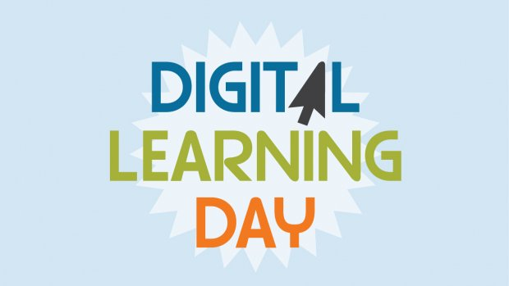
Gwinnett County Public Schools’ (GCPS) 2019‐20 school calendar includes two make‐up days to address school days missed due to inclement weather. In addition to these days, GCPS also has the option of using Digital Learning Days to make up days missed due to inclement weather. Should a decision be made to cancel school, students, parents, and staff will be notified of the closing and if the day is a Digital Learning Day.

How will it work for students?
  - On the day that school has been canceled, teachers will post assignments on their eCLASS C&I course pages. High school assignments will be posted by 8 a.m. Elementary school assignments will be posted by 9 a.m. And, middle school assignments will be posted by 10 a.m.
  - Students will use the MyeCLASS student portal to log in to their eCLASS C&I course pages where they will access assignments, resources, and other materials. If the power is out, a student may access the teacher’s course page when power returns. If a student does not have access to a computer or device (tablet, smartphone, etc.), the student can get the assignment once school resumes.
  - Student work will be expected to be turned in to the teacher (either digitally or in person), using a school’s process for turning in work following an absence. For example, if your school allows students to turn in work two days after a missed day, the Digital Learning Day assignments would be due two days after classes resume.
During the school year, teachers will share additional information with students about Digital Learning Days, including how they will support student learning during the day. (For example, some teachers may set up a discussion board while others may use online conference tools or be available via phone.)

Parents and students who need a refresher course on how to access eCLASS C&I course pages can go to the following web page for helpful resources and information:
http://publish.gwinnett.k12.ga.us/gcps/home/public/about/eclass/content/eclass-c-and-i-course-pages

August 2019

